BSC ARENA
Waynesboro Ga. 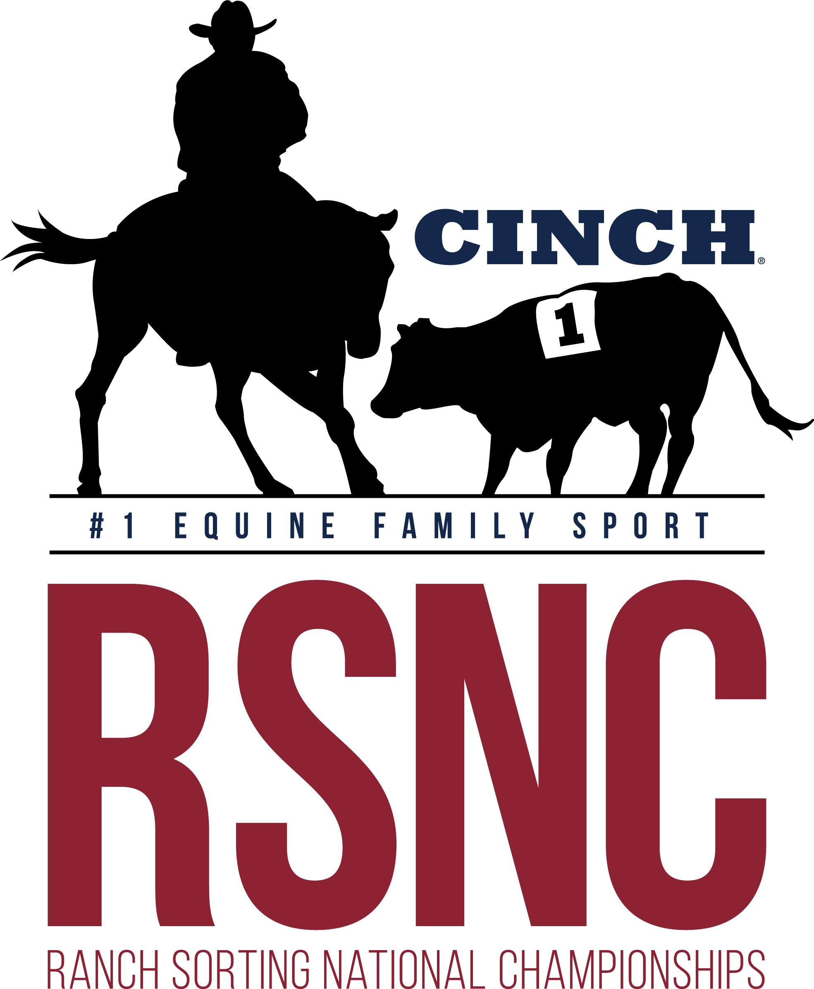

Ranch Sorting

1 SHOW 2 DAYS !!!
Covered
Arena

Friday December 13th
Saturday December 14th

Concession
Available

Friday December 13th
*Books open @ 4:30pm - Sort @ 5:30pm*
8 COW DRAW (handicapped at highest entry combo)
Must ride 8 times x $29EF - $232 Total (runs and pays like round robin)

Saturday December 14th
*Books open @ 8am - Sort @ 9am*
Masters #10 HC - $29 EF
All Levels HC - $47 EF 60% payback (capped at highest entry combo) #2 floor
Beginner RH #10 HC - $27 EF (#1 cap on sorter)
REVERSE Rookie #11 HC - $29 EF (#2 cap on Gate Holder)
#10 HC - $29 EF
#6 HC - $29 EF
All Classes 50% payback except All Levels 60% payback
*Entry Fees include a $3/entry RSNC sanctioning fee and $4/entry cattle fee ~ 5 Ride Limit ~
Mandatory Draw- Pick 1 Automatically Draw 1 (Pick up to 4 or Draw All 5) except All Draw Classes
All Classes with entry fees less than $35 may run one round and top ten unless over 60 teams

Location:  BSC Covered Arena  3976 Hwy 24 South  Waynesboro, Ga | Call to Reserve Stalls $20nt/$30wknd and RV $20nt  706-551-2190  **All info on flyer subject to change**  New RSNC Memberships changes apply
Contact Johnny Lovett at #706-551-2190 or Cliff Chancey at #706-840-3971 with any questions – Entry Fees Payable With Cash, Good Check or Venmo


